
re:new - New Year Sermon Series

Week 2: Renewed Rhythms — Living in Step with God

Theme Overview
We all live by rhythms — work, rest, relationships. God designed us for balance: time in His Word, prayer, community, and mission. Jesus modeled perfect rhythm — intimacy with the Father fueling activity in the world.

Icebreaker
Share one rhythm or habit that helps you feel connected to God or grounded during your week.

Bible Reflection
Read Psalm 1, Luke 6:12-16 and Matthew 14:22-24 slowly, pausing between each reading for 2 minutes to allow each person to reflect on the words more deeply.
Psalm 1 describes a person planted by streams of water — stable, fruitful, and nourished.
Luke 6 shows Jesus withdrawing to pray before choosing His disciples — His rhythm of solitude and action.

Discussion Questions
- What stands out to you from these readings? What were you particularly drawn to?
- What does the picture of being “planted by streams of water” mean to you personally? (Psalm 1)
- What does ‘meditating’ on scripture look like (Psalm 1:2)? How might this be different from simply ‘reading Bible notes’ or ‘doing a Bible study’?
- What do you notice about Jesus’ pattern of prayer, rest, and mission?
- Peter Greg says ‘It’s so easy to forget that it’s not God who needs my dutiful prayer, but me who needs his reviving presence… In the presence of his Father alone, he was re-energized with all the resources of heaven for the challenge of a new day’ (Lectio365 21st November). Discuss!
- What are some examples of unhealthy rhythms? How might these affect your spiritual life or relationships?
- Sky Jethani in his excellent book ‘With: Reimagining the way you relate to God’ describes the difference between ‘living your life WITH God’ and ‘Living your life FOR God.’ What do you think is the difference? Which one might best describe how you are currently trying to live your life? How might intentional rhythms help to more live your life WITH God rather than FOR God.

Practical Application
Take a few minutes of silence and reflect on the following two questions:
- What ‘healthy rhythm’ in your life helps you most deepen your relationship with God? How might you do more of this?
- What ‘unhealthy rhythm’ in your life most draws you away from God? How might you do less of this or remove this altogether?
Share your reflections if you feel able, with 1 or 2 others in your group and pray for each other that God would help you ‘reset’ your rhythms to further flourish as he has created you to.

Weekly Challenge
Take one evening off from screens and spend that time journaling, praying, worshipping or connecting with family.

A resource to check out… the PAUSE App
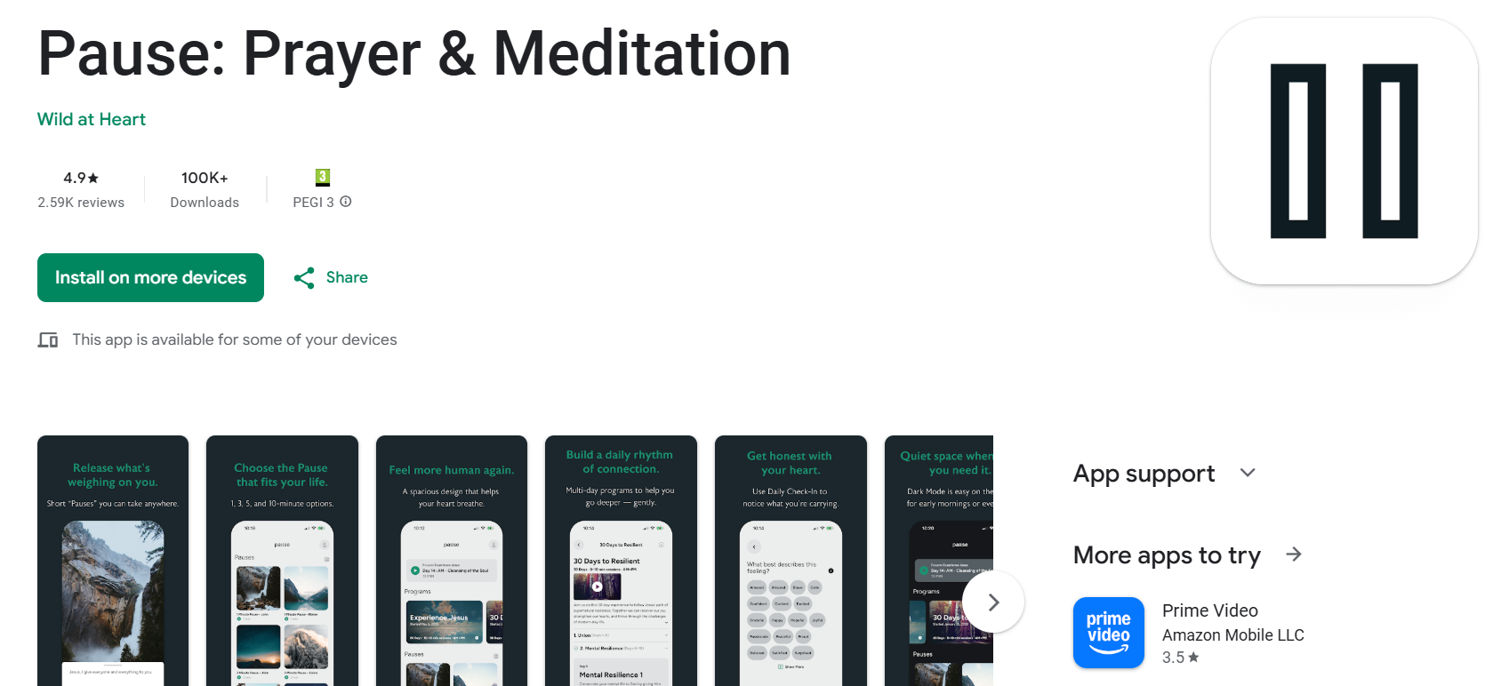

A few of us in the men’s life group have recently been finding the PAUSE app very helpful.
It gives the opportunity to have brief ‘pauses’ in the day as well as having programs (‘Encountering Jesus’ and ‘Building Resilience’) to work through over a series of days with morning and evening reflections. Not only does this lead us into prayer, but also teaches us techniques of how to pray.
Why not try it out?

